

Functional Requirements Document (FRD)
  - Intermex – J876187, J885047

Copyright© 2018, Oracle and/or its affiliates. All rights reserved.
Any reproduction or distribution of any part of this document without the prior written permission of Oracle + NetSuite is strictly prohibited.
The information included in this document is confidential and proprietary information of Oracle + NetSuite.
Version: March 3, 2022

Oracle + NetSuite
2955 Campus Drive, Suite 100
San Mateo, CA. 99403-2511

Project Information
Implementation Name | Custom Checkout
Customer Name (Number) | Intermex
Job Name (Number) | J876187
Document Owner | Alain Komin
Project Manager | Alain Komin
Lead Developer | Ilan Daniele

Document Version History
Rev | Date | Author(s) | Change Summary
1.0 | 08/29/2022 | Alain Komin | Initial Draft

Table of Contents
1 Business needs 4
2 Impacted areas/modules 4
3 Acceptance criteria 5
4 Solution proposal 5
5 Prerequisites 6
6 Assumptions 6
7 Constraints and limitations 6
8 Risks 7
9 Current site look and functionality 8
9.1 Equipment order page 10
9.2 Marketing order page 18

Business needs

As a logged in Sales Representative, I would like to see a custom checkout page where multiple non-native options are available for selection, so that, I am able to add all relevant information to my order.

Impacted areas/modules
The

Checkout page will be updated to allow adding dropdowns to the CS Custom Fields extension.
Some of the lists that are needed to be displayed at checkout are:
- Order Type
- Priority
- System
- Fiesta Van / Canopy Event

- Agent Classification
- Region

Acceptance criteria

This customization will allow the administrator to select all necessary Transaction Body fields to be displayed at checkout based on the type of order (Marketing or Equipment). It will be possible to specify the order in which the fields will be displayed.
The configuration record will display the Dropdown/List option in the Extensions>Custom Fields tab and a new column to select type of order.
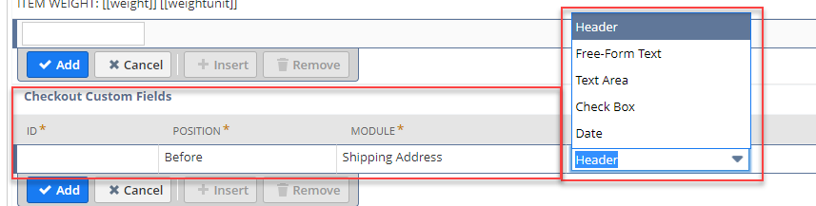

Solution proposal

A new extension will be created to add the described functionality to the Configuration record, Item Record and webstore’s Cart and Checkout pages.

Configuration Record
Next to the field type list, a new column will be added to select the type of order (Equipment or Marketing).
The next columns will be added to a new tab in the configuration record to allow the administrator to define the checkout page:
- Field ID
- Position
- Field type
- Field Label
- Placeholder
- Required
- Max Field Length
- Order Type

ID | POSITION | FIELD TYPE | FIELD LABEL | PLACEHOLDER | REQUIRED | MAX FIELD LENGTH | ORDER TYPE
Cust_field_agency | 1 | Free-Form Text | Agency |  |  | 6 | Equipment
Cust_order_type | 2 | List | Order Type | Select order type… |  |  | Equipment
Cust_order_sent_to | 3 | List | This order will be sent to |  |  |  | Marketing
Cust_im_rse | 4 | Check Box | I´m RSE |  |  |  | Both

Item Record
As some items will belong to the “Equipment” order and some to the “Marketing” order, a new list will be added to the Item record to mark it as Equipment or Marketing.

Cart
There will be a new validation that will execute upon adding each item to the Cart. If there is already an item in the cart, the new item to be added must have the same option as the existing ones in the cart (Equipment or Marketing). If the item in the cart is Marketing type and the agent is adding an Equipment one, a pop-up error will be displayed informing that the items are incompatible. The same error will be displayed if the item in the cart is Equipment and the item to be added is Marketing type. This error message will be set in the Configuration record and will be available to be updated.

Checkout
As the checkout process will be totally custom and there are no shipping information or billing information, it will be necessary to remove all native checkout sections and just display the fields configured.
This new list in the item record will be used to show the correct fields at checkout, based on the selection in the Configuration record for each field.
The Sales Order needs a billing address, this one will be the selected Agency address. TBC. Maybe a fake default address?

Prerequisites

All necessary standalone Items will be created and flagged to be displayed in the webstore by Intermex.
All necessary kit Items will be created and flagged to be displayed in the webstore by Intermex.
All necessary Item Options (e.g.: Additional Notes for Supplies) will be created by Intermex.
All necessary Items will be added to a Commerce Category by Intermex.
All necessary Items will be flagged as Marketing or equipment by Intermex for this customization to work properly and for the checkout to look and behave as needed.
All necessary Transaction Body fields and lists will be created by Intermex for this customization to work properly and for the checkout to look and behave as needed.
Complete list of fields needed at checkout:
- Order Type (list)
- Priority (list)
- System (list)
- Fiesta Van / Canopy Event (list)
- Agent Classification (list)
- Region (list)
- Dist. Manager Stock (checkbox)
- Ship to Intermex Representative (checkbox)
- Order Reviewed (checkbox)
- Event Date (date)

Assumptions

- All necessary Items will be created by Intermex
- All necessary Categories will be created by Intermex
- All necessary Transaction Body Fields will be created by Intermex
- All necessary Lists will be created by Intermex
- Access to the store for Agents will be granted and communicated by Intermex

Constraints and limitations
GUIDELINE FOR THIS SECTION (DELETE TEXT BELOW ONCE THIS SECTION IS COMPLETED)
This section should list all the constraints and limitations known until the date.
[This section is optional as final output on the document. The contents of this section will depend on if limitations exists or not. Although the section is optional it must be part of the analysis process to determine if it is needed or not.]
For example:
- BOPIS is not compatible with scriptable cart.
- Customer Item pricing is limited to 10.000 records.
- Etc.
(DELETE TEXT ABOVE ONCE THIS SECTION IS COMPLETED)

Risks
GUIDELINE FOR THIS SECTION (DELETE TEXT BELOW ONCE THIS SECTION IS COMPLETED)
This section should list all the risks that this solution may face or introduce to the system.
[This section is optional as final output on the document. The contents of this section will depend on if risks exists or not. Although the section is optional it must be part of the analysis process to determine if it is needed or not.]
For example:
- If a third party integration is needed then there is a risk that the third party could break eventually and impact the site.
- If working with SCS and CSS rules are being used to achieve certain behavior then the theme could be updated in the future and the CSS rules might no longer work (although this is highly improbable the risk exists).
- Etc.
(DELETE TEXT ABOVE ONCE THIS SECTION IS COMPLETED)

Current site look and functionality
Homepage has 2 options on the right, for Marketing and Equipment orders.
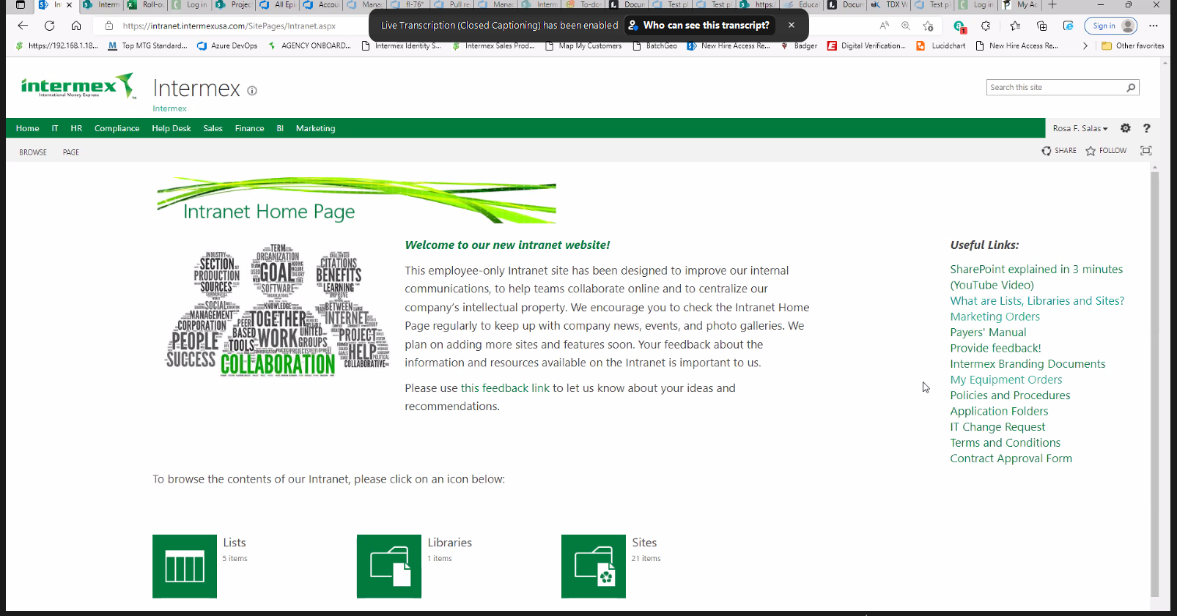
Each link takes the Agent to the list of those type of orders.
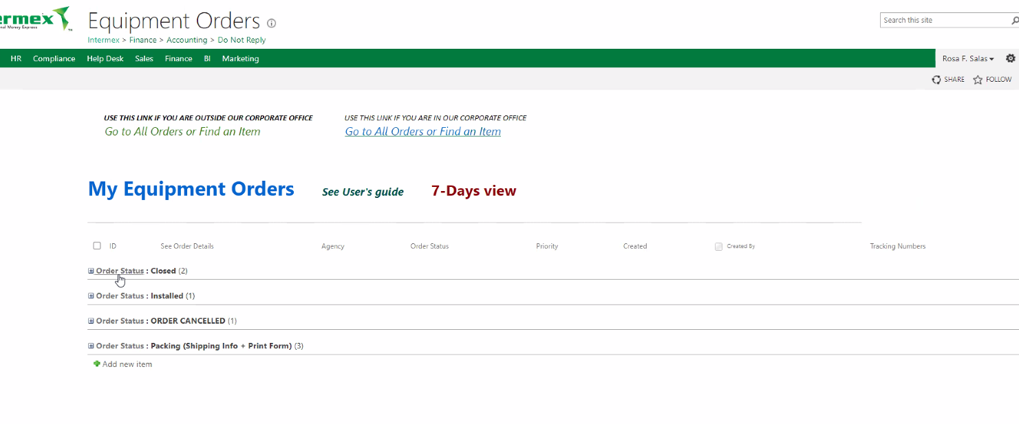
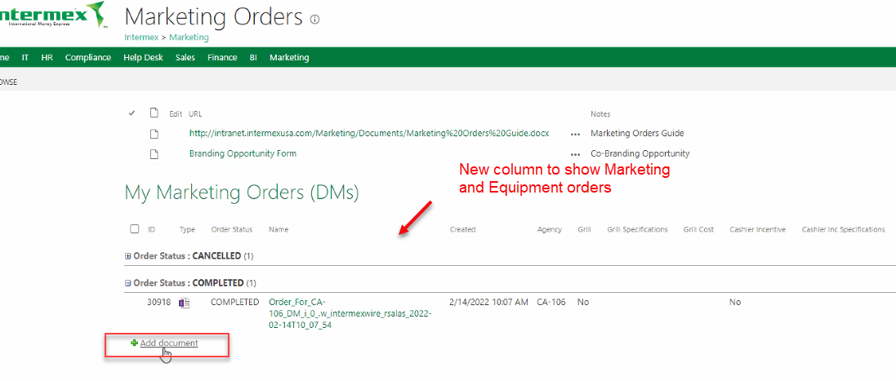
Add document link takes the Agent to the order page.
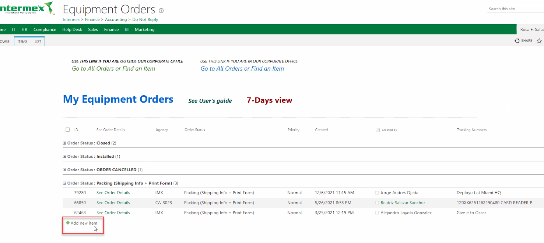

Equipment order page
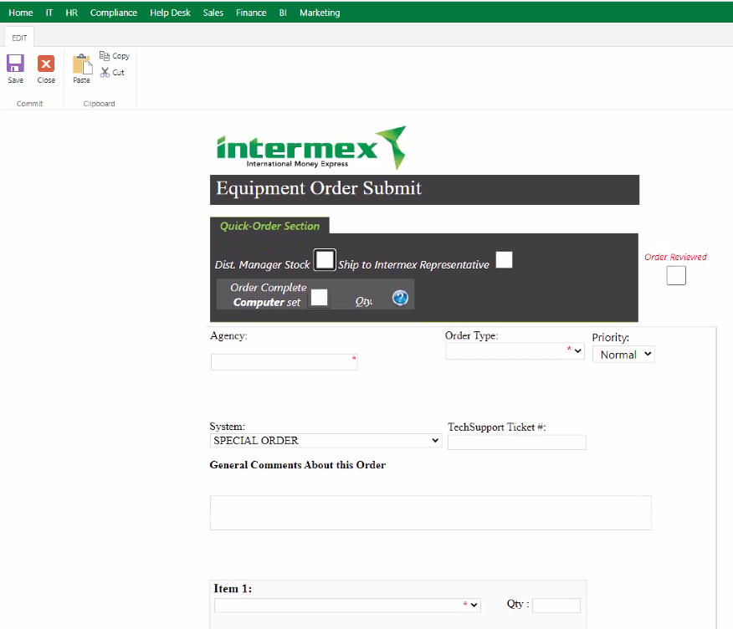

Dist. Manager Stock checked disables the Agency text-box and auto selects the Order Type to District Manager Stock. It also shows a Ship equipment to DM! label.
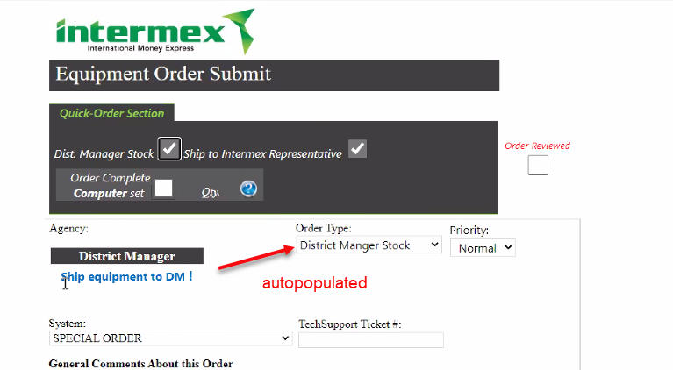

If Ship to Intermex Representative is checked, what happens here?
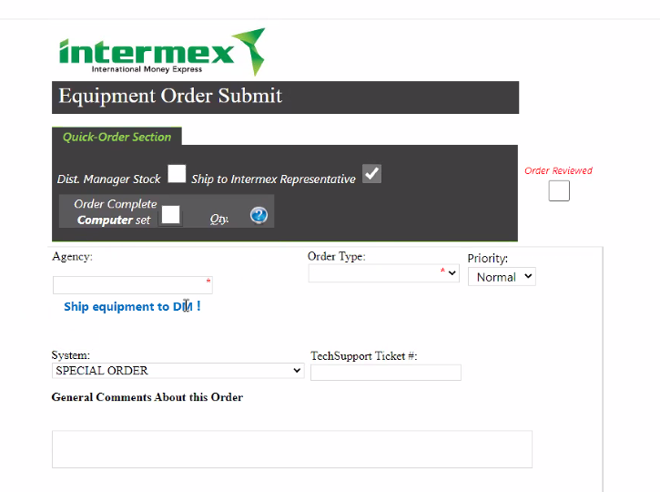

Order Complete Computer set checkbox automatically add all parts of the computer. Qty selector has limited options: 0 and 1.
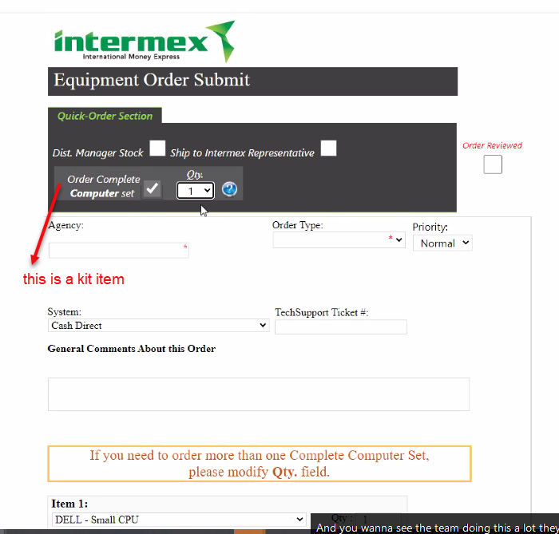
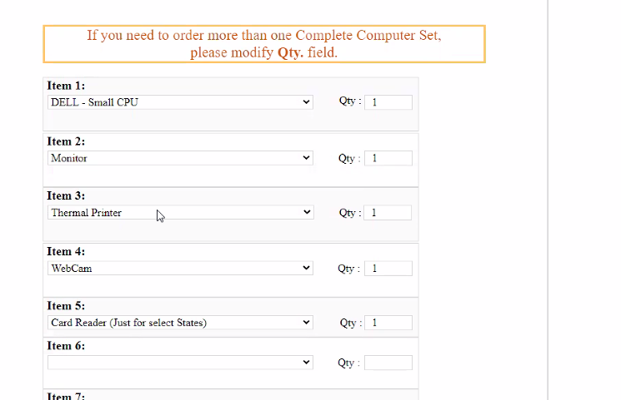
If the item the Agent is looking for is not in the list, they select Supplies and adds a mandatory text with the item needed.
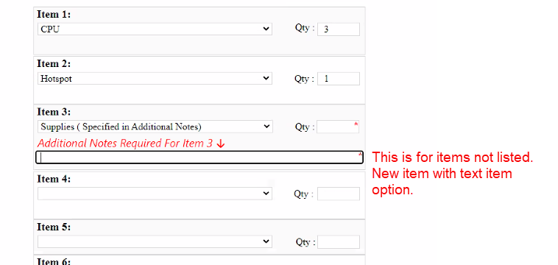

Help icon shows a modal with information. This will be Kit Item Detailed Description.
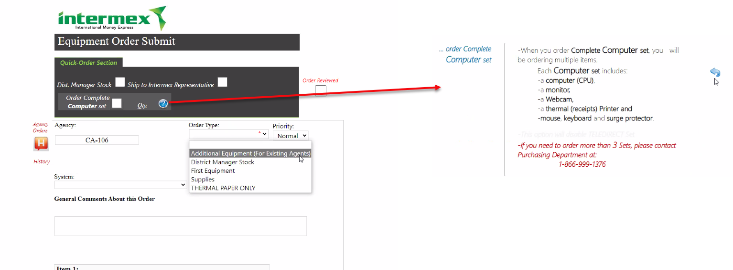
Some Order Types and High Priority options shows red messages and require mandatory Comments. Make this field mandatory so all orders will have this field populated.
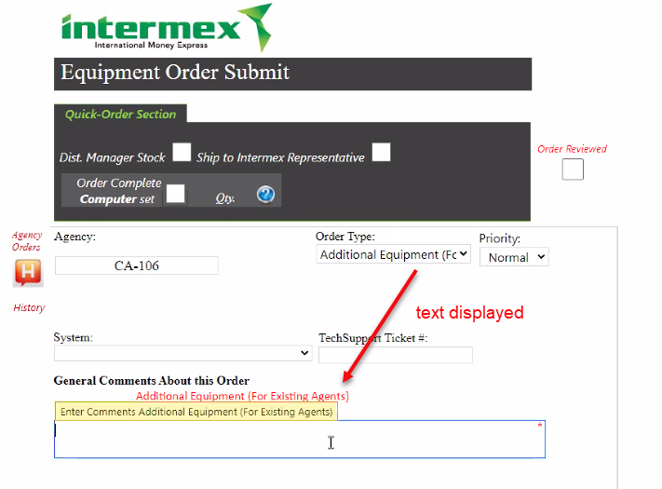
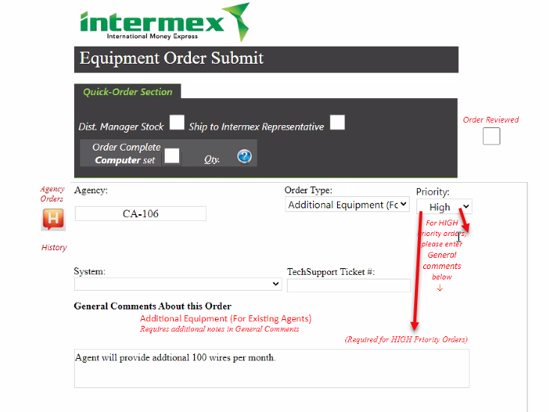

Before submitting the order, the Agent must check the Order Reviewed checkbox. Use native T&C checkbox.
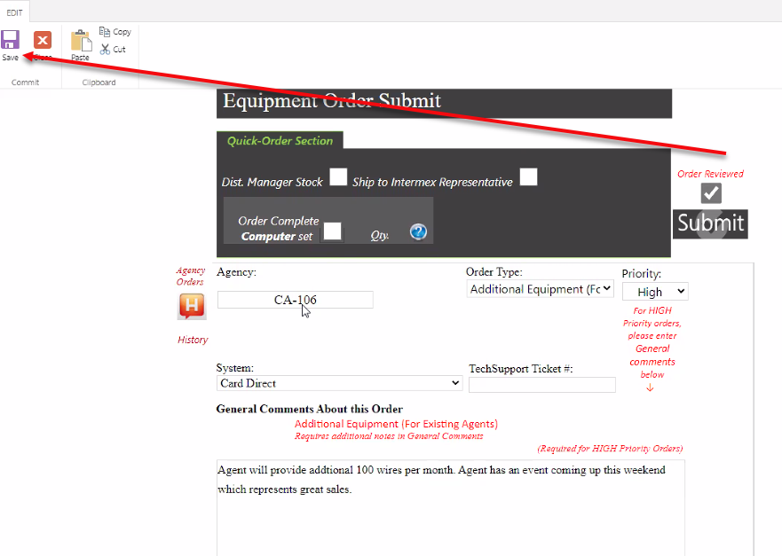

Marketing order page
Orders can be for My Self or An Agent.
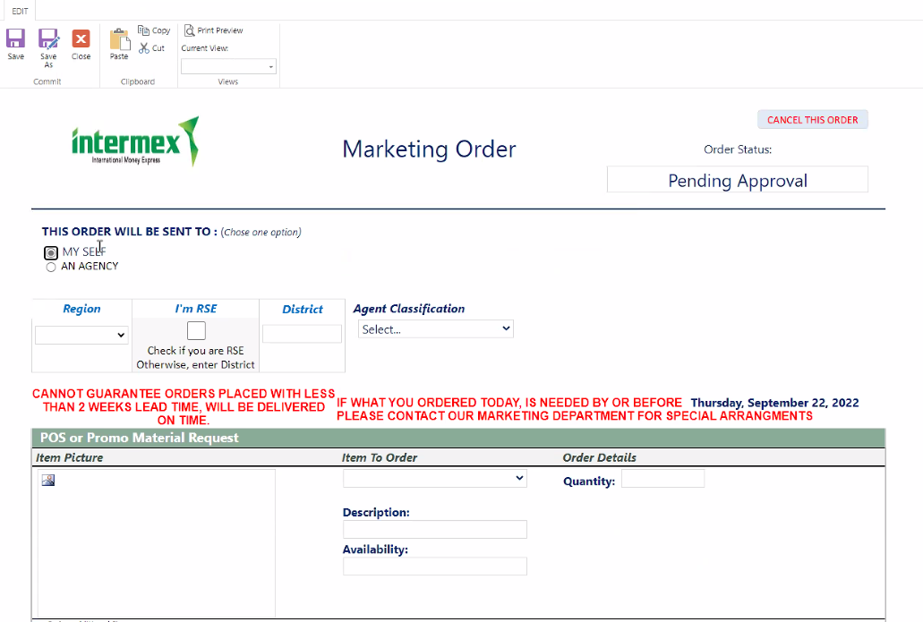

If I´m RSE is checked, District selection is not available.
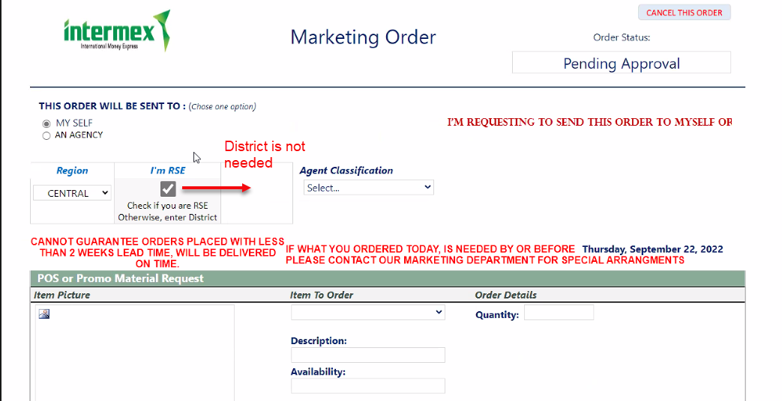
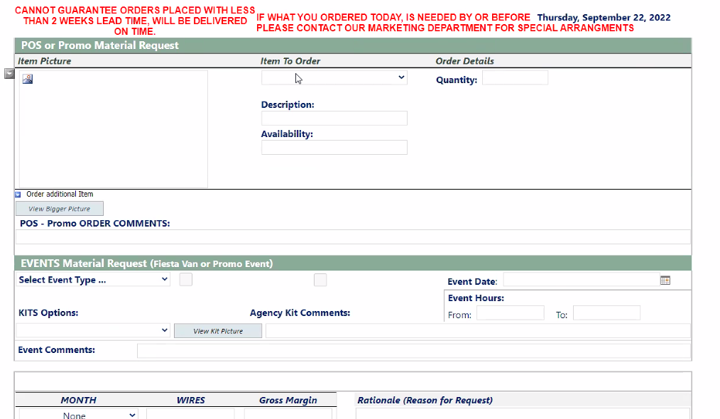
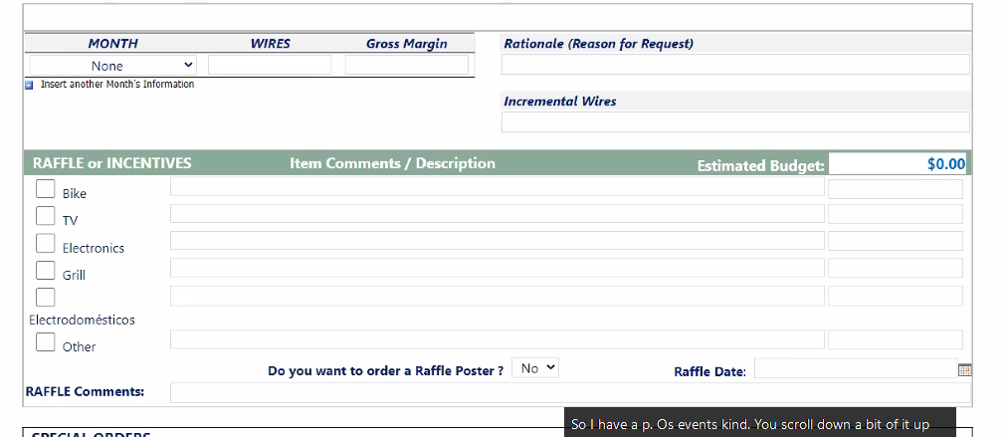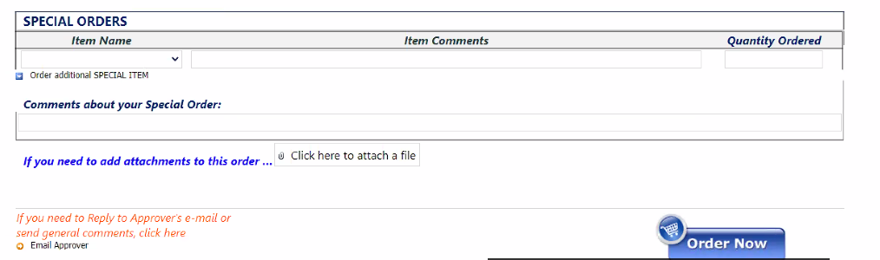
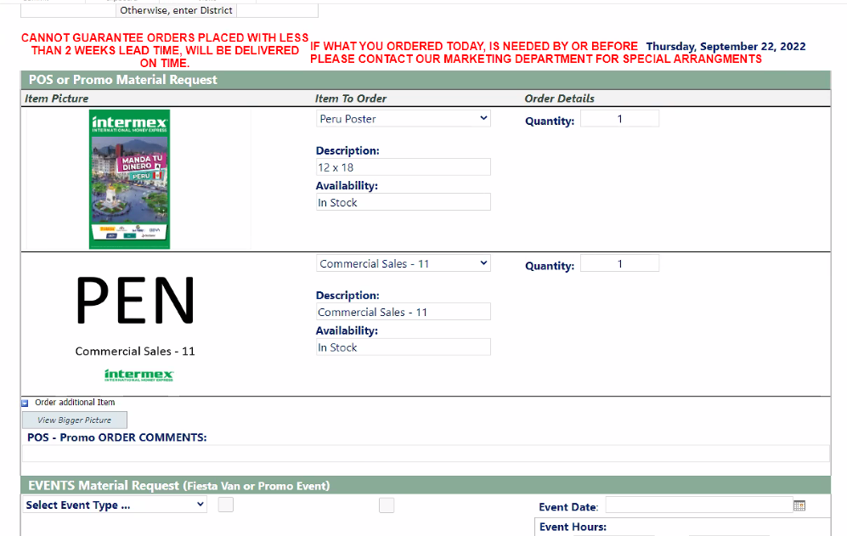

Oracle + NetSuite Professional Services and Customer are in agreement that the information documented above is accurate and representative of the customer’s business needs. This document will act as the basis for all subsequent implementation activities.
Document delivery date: MM/DD/YYYY

